2022 WI DIARY ORDER FORM
Next year’s diary will have a green cover that is completely recyclable, which makes the whole diary recyclable except for the ribbon.
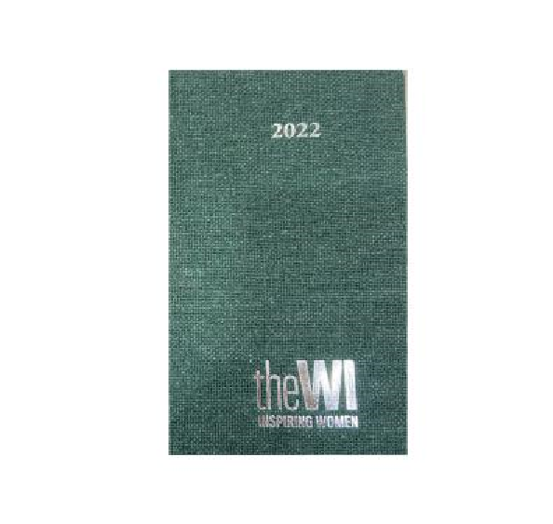
Diaries will be advertised from November at the NFWI Shop & WI Life however, we are able to order for you and offer collection from WI Office or posting to your WI, or individual member (prices below).

Consolidated from WIs would be appreciated.
The price of each diary will be £5.50 plus any P&P
Please indicate on the form below whether you wish to collect diaries from the WI Office or whether you would like them posted.
Payment can be made online or by cheque.
Lloyds Bank – Lincolnshire South Federation of WIs
Account Number 43337760 Sort Code 30-90-89
Cheques made payable to – LSF of WI
CLOSING DATE: November 30th 2021


2022 WI DIARY ORDER FORM

WI………………………………………………………………………………………………………………………………………………………………
Number of Diaries required at £5.50 each.
Please tick √ | Number | Paid online | Cheque attached | Bulk WI Orders, please invoice my WI
FOR COLLECTION FROM WI OFFICE (no P&P)

POSTING TO WI SECRETARY (bulk orders. If posted WI will be invoiced total including P&P)
INDIVIDUAL REQUEST – please give your postal address below
£5.50 plus £1.00 P&P

Email………………………………………………………………………………………………………..

Please return this form to Lincolnshire South Federation of WIs, WI Office, Pattison House,
Oak Park, East Rd, Sleaford NG34 7EQ or email tofedoffice@lsfwi.org.uk

